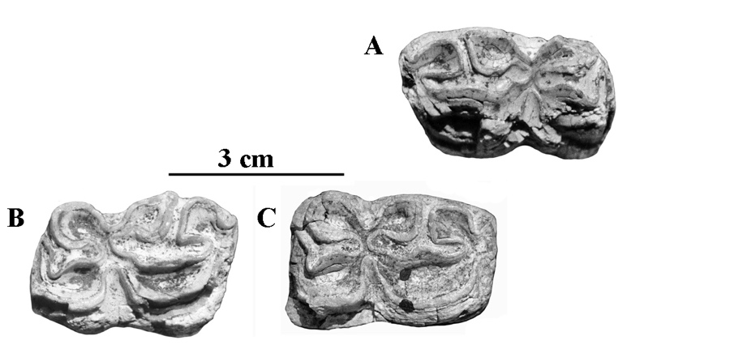

Figure S4. Occlusal views of lower cheek teeth of *E*. cf. *suessenbornensis*. A: IQW Süss. 6448, right P3 or P4; B: IQW Süss. 6222, left P3 or P4; C: IQW Süss. 6566, left P4 or M1; D: IQW Süss. 7204, left M1 or M2.